Regions of Georgia and Map Skills Study Guide
Test Date: Thursday, Sept. 12, 2013
Definitions to know:
Compass rose: Tool that is used that tells directions on a map.(north, south, east, west, southwest, northwest, northeast, and southeast)
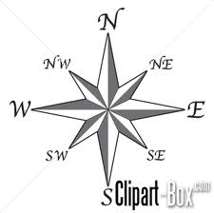
Map Key: A table found on a map that uses symbols to represent things found on a map.
Region: an area that has shared features
Skills:
Know what directions are opposite of each other on a compass rose.
Be able fill in missing directional words on a compass rose.
Know there are 5 regions in Georgia.
Know the main idea for each of the 5 regions of Georgia:
Coastal Plains | Largest region in Georgia, near the sea, and peanuts and pecans are grown here.
Piedmont | Most of Georgia’s people live here, including the city of Atlanta, and we live in the Piedmont.
Appalachian Plateau | It takes up the northwest corner of the state, there are lots of mountains including Lookout and Sand Mountain, and people like to vacation here.
Valley and Ridge | It is north of Georgia and the soil is good for farming fruits like apples.
Blue Ridge Mountains. | It is in the northeastern part of the state and has big rivers and mountains including Georgia’s highest point, Brasstown Bald Mountain.
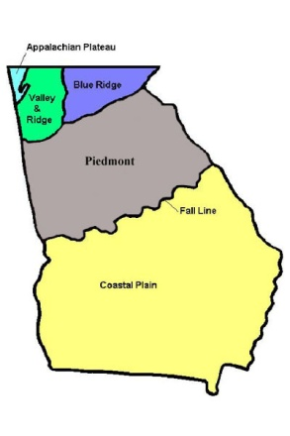
Know the location of each region:

Know that there are 7 major rivers in Georgia, and that the one closest to us is the Chattahoochee River.

